F. EXAMPLE PROJECTS WHICH BEST ILLUSTRATE PROPOSED TEAM’S QUALIFICATIONS FOR THIS CONTRACT  (Present as many projects as requested by the agency, or 10 projects, if not specified. Complete one Section F for each project.) |  |  |  |  |  |  | 20. EXAMPLE PROJECT KEY NUMBER  03
21. TITLE AND LOCATION (CITY AND STATE)  Interstate 5 North County Enhancement Project,  Santa Clarita, CA |  |  |  | 22. YEAR COMPLETED
 |  |  |  | PROFESSIONAL SERVICES  Ongoing |  |  | CONSTRUCTION (IF APPLICABLE)
23. PROJECT OWNER’S INFORMATION
a. PROJECT OWNER  LA Metro / Caltrans District 7 |  | b. POINT OF CONTACT NAME  Darrell McKenzie, Senior Resident Engineer  Emile Eid, CT Senior Engineer |  |  | c. POINT OF CONTACT TELEPHONE NUMBER  (626) 390-0791  (213) 276-2054
24. BRIEF DESCRIPTION OF PROJECT AND RELEVANCE TO THIS CONTRACT (INCLUDE SCOPE, SIZE AND COST)
S2 Engineering (S2) provides comprehensive quality management, traffic management, inspection, office engineering, for southern California’s largest Design–Bid–Build highway project of Caltrans. This project represents a partnership between the Los Angeles Metro and Caltrans District 7. The project will provide additional lanes and additional dedicated truck traffic lanes through Valencia / Santa Clarita. Improvements include widening / replacement of several bridges, soundwall improvements, median retaining walls, Roadway structural sections, soil nail walls, tie back walls, extensive drainage system, and weighing station enhancements. S2 is currently providing the entire quality management, and inspection and office engineering services. Routine quality management and inspection functions include the assignment of quality inspectors, traffic management and inspection, RFI and Submittals tracking and reviews with flexible multi-skilled staff that provide service for day shift and night shift.
- Caltrans Oversight Project
- On- Call Materials Testing and Batch Plant Inspection
- Caltrans and ASTM methods
- Documentation per Caltrans filing system.
- Internal audit of sampling, testing, and documentation
- Passed all Caltrans Oversight audits.
- Covered regular, weekend, and extended 55- hour shifts.
Project Relevance
Project features include:
- 172,000 cubic yards or JPCP (approximately 70 miles of lineal rigid pavement)
- 100,000+ tons of HMA / RHMA
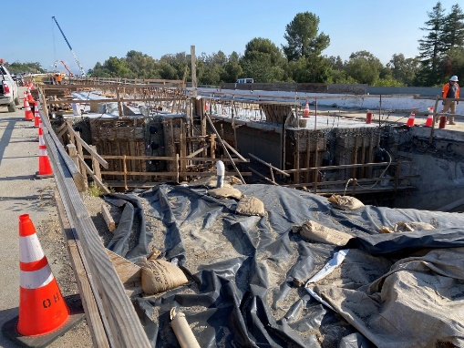
- 57,000 cubic yards of retaining wall concrete (30 miles of 10’ high wall)
- 15 million pounds of reinforcing steel
- Use of RSC and Fiber Concrete
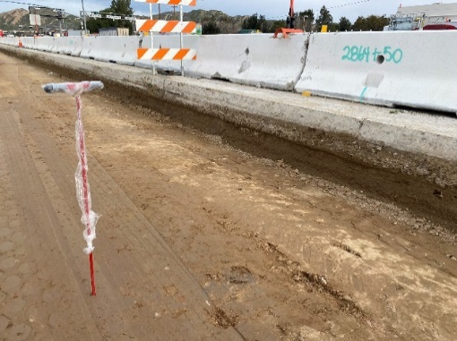
Structure improvements include the widening of six bridges, including one complete bridge replacement; addition of 1800 LF of soundwall; and rehabilitation of freeway ramps, shoulders, safety improvements, and rigid pavement rehabilitation operations. S2 is also providing resolute task order management staff to administer, review, and submit deliverables provided by materials testers and source inspectors.
25. FIRMS FROM SECTION C INVOLVED WITH THIS PROJECT
a. | (1) FIRM NAME  S2 Engineering, Inc |  | (2) FIRM LOCATION (CITY AND STATE)  Santa Clarita, Los Angeles County, CA |  |  | (3) ROLE  Quality Management, Traffic Management, Field Inspection, OE,
b. | FCG Consultants |  | Los Angeles, CA |  |  | Roadway Inspection
STANDARD FORM 330 (REV. 7/2021)

